A Lab Manual
on
FULL STACK WEB DEVELOPMENT LAB
(III- B. Tech. – II– Semester)
Submitted to
DEPARTMENT OF COMPUTER SCIENCE& ENGINEERING
(ARTIFICIAL INTELLIGENCE AND MACHINE LEARNING)
By
MS. Kilari Rampriya
(Asst Professor, Dept. of AIML)



CMR INSTITUTE OF TECHNOLOGY
Kandlakoya(V), Medchal Road, Hyderabad – 501 401
Ph. No. 08418-222042, 22106 Fax No. 08418-222106

(2022-23)
CONTENTS
Sl. No. | Particulars | Page No.
1 | Syllabus | 2
2 | Student Entry Behavior or Pre-requisites | 3
3 | Course Objectives | 4
4 | Course Outcomes | 5
5 | Mapping of Course with PEOs-PSOs-POs | 7
6 | Mapping Of Course Outcomes with PEOs | 7
7 | Mapping Of Course Outcomes with PSOs | 8
8 | Mapping Of Course Outcomes with POs | 9
9 | Direct Course Assessment | 10
10 | Indirect Course Assessment | 11
11 | Overall Course Assessment and Attainment level | 11
12 | Pi diagrams, Bar charts, Histograms for representing results | 12
13 | Lesson/Course Plan | 13
14 | Programs | 14

- Syllabus
FULL STACK WEB DEVELOPMENT LAB

III-B.Tech.-II-Sem. L T P C

Subject Code: CS-PCC-32 - - 3 1.5
Course Outcomes: Upon completion of the course, the student will be able to
COs | Upon completion of course the students will be able to | PO4 | PO5 | PO14
CO1 | illustrate implementation procedure of full stack web development | 3 | 3 | 3
CO2 | demonstrate HTML5, CSS5 scripting languages and Github | 3 | 3 | 3
CO3 | make use of scripting languages in web development | 3 | 3 | 3
CO4 | develop web applications using AJAX | 3 | 3 | 3
CO5 | build real time applications using full stack web development | 3 | 3 | 3

List of Experiments
Week | Title/Experiment
1 | Write code in HTML5 to develop simple webpage.
2 | Write CSS & HTML5 Code to show Dropdown Menu.
3 | Design Single Page Application with different menu items.
4 | Write a program in CSS to show your city with building and moving cars.
5 | Write a program to validate web form using javascript.
6 | Write jquery code to show website slider.
7 | Write a program in javascript to create a user login system.
8 | Write a program in javascript to create a user registration system.
9 | Write a program to display user details using HTML, CSS & AJAX.
10 | Demonstrate version control in Git and Github.

Micro-Projects: Student must submit a report on one of the following Micro–Projects before commencement of second internal examination.
- Develop Project MyNote - A HTML5 App
- Develop a Bookstore application by using HTML5, CSS, jquery in Github
- Develop a shopping cart application by using HTML5, CSS, jquery in Github
- Develop an e-learning system using HTML5, CSS, jquery in Github
- Build a personal portfolio webpage using HTML5, CSS, jquery.
- Develop google.com Search result page using HTML5, CSS, jquery & Ajax
- Develop a webpage to display solar system using HTML5, CSS, jquery & Ajax
- Build Tajmahal using CSS.
- Build a Real-Time Markdown Editor with Node.js
- Develop an User model covering, Registration, Email verification(send an email), Login (with remember me)
Reference: 1. Full Stack Web Development Lab Manual, Department of CSE, CMRIT, Hyd.
- Student Entry Behavior or Pre-requisites

- Students should have basic knowledge on HTML and CSS
- Students should have basic knowledge on C and Java programming.
- Student should have knowledge on oops and software engineering concepts
These prerequisites are taken by the students during the first two years. However during the initial sessions the topics are reviewed.
- Course Outcomes

Course Outcome | Course Outcome Statements
CO - 1 | illustrate implementation procedure of full stack web development
CO – 2 | demonstrate HTML5, CSS5 scripting languages and Github
CO – 3 | make use of scripting languages in web development
CO – 4 | develop web applications using AJAX
CO – 5 | build real time applications using full stack web development

- Mapping of Course with PEOs-POs

(Only Ticking)

Program Educational Objectives (PEOs)

Sl. No. | PEOs Name | Program Education Objective Statements
1 | PEO - 1 | Impart profound knowledge in humanities and basic sciences along with core engineering concepts for practical understanding & project development.[PO’s: 1,2,3,4,5,7,8,9,10,11 and 12] [PSO’s: 1 and 2]
2 | PEO – 2 | Enrich analytical skills and Industry-based modern technical skills in core and interdisciplinary areas for accomplishing research, higher education, entrepreneurship and to succeed in various engineering positions globally. [PO’s: 1,2,3,4,5,6,7,8,9,10 and 12] [PSO’s: 1, 2 and 3]
3 | PEO – 3 | Infuse life-long learning, professional ethics, responsibilities and adaptation to innovation along with effective communication skills with a sense of social awareness. [PO’s: 1,2,3,4,5,6,7,8,9,10,11 and 12] [PSO’s: 2 and 3]

Program Outcomes (POs)

PO Name | Graduate Attributes | PO Statements
PO1 | Engineering knowledge | Apply the knowledge of mathematics, science, engineering fundamentals, and an engineering specialization to the solution of complex engineering problems. [PEO’s: 1,2 and 3] [PSO’s: 1,2 and 3]
PO 2 | Problem analysis | Identify, formulate, review research literature, and analyze complex engineering problems reaching substantiated conclusions using first principles of mathematics, natural sciences, and engineering sciences. [PEO’s: 1,2 and 3] [PSO’s: 1,2 and 3]
PO 3 | Design/ development of solutions | Design solutions for complex engineering problems and design system components or processes that meet the specified needs with appropriate consideration for the public health and safety, and the cultural, societal, and environmental considerations. [PEO’s: 1,2 and 3] [PSO’s: 1,2 and 3]
PO 4 | Conduct investigations of complex problems | Use research-based knowledge and research methods including design of experiments, analysis and interpretation of data, and synthesis of the information to provide valid conclusions. [PEO’s: 1,2 and 3] [PSO’s: 1,2 and 3]
PO 5 | Modern tool usage | Create, select, and apply appropriate techniques, resources, and modern engineering and IT tools including prediction and modeling to complex engineering activities with an understanding of the limitations. [PEO’s: 1,2 and 3] [PSO’s: 1,2 and 3]
PO 6 | The engineer and society | Apply reasoning informed by the contextual knowledge to assess societal, health, safety, legal and cultural issues and the consequent responsibilities relevant to the professional engineering practice. [PEO’s: 2 and 3]
PO 7 | Environment and sustainability | Understand the impact of the professional engineering solutions in societal and environmental contexts, and demonstrate the knowledge of, and need for sustainable development. [PEO’s: 1,2 and 3]
PO 8 | Ethics | Apply ethical principles and commit to professional ethics and responsibilities and norms of the engineering practice. [PEO’s: 1,2 and 3] [PSO’s: 2 and 3]
PO 9 | Individual and team work | Function effectively as an individual, and as a member or leader in diverse teams, and in multidisciplinary settings. [PEO’s: 1,2 and 3] [PSO’s: 3]
PO 10 | Communication | Communicate effectively on complex engineering activities with the engineering community and with society at large, such as, being able to comprehend and write effective reports and design documentation, make effective presentations, and give and receive clear instructions. [PEO’s: 1,2 and 3] [PSO’s: 2 and 3]
PO 11 | Project management and finance | Demonstrate knowledge and understanding of the engineering and management principles and apply these to one’s own work, as a member and leader in a team, to manage projects and in multidisciplinary environments. [PEO’s: 1 and 3] [PSO’s: 2 and 3]
PO 12 | Life-long learning | Recognize the need for, and have the preparation and ability to engage in independent and life-long learning in the broadest context of technological change. [PEO’s: 1,2 and 3] [PSO’s: 1,2 and 3]

- Mapping Of Course Outcomes With POs

No | Course Outcomes | Po₁ | Po₂ | Po₃ | Po₄ | Po₅ | Po₆ | Po₇ | Po₈ | Po₉ | Po₁₀ | Po₁₁ | Po₁₂ | Avg
1 | CO - 1 |  |  |  | 3 | 3 | 3 |  | 3
2 | CO – 2 |  |  |  | 3 | 3 | 3 |  | 3
3 | CO – 3 |  |  |  | 3 | 3 | 3 |  | 3
4 | CO – 4 |  |  |  | 3 | 3 | 3 |  | 3
5 | CO – 5 |  |  |  | 3 | 3 | 3 |  | 3
 | Avg |  |  |  | 3 | 3 | 3 |  | 3
- Direct Course Assessment

(As mentioned in following table of 10 parameters, of which consider only the parameters required for this courses)

No | Description | Targeted Performance | Actual Performance | Remarks | Course Attainment
1 | Internal Marks(25) | 80% of Students(182 Students) should Secure 60% of Internal Marks i.e., 15 Marks
2 | External Marks(50) | 80% of Students(182 Students) should Secure 70% of External Marks i.e., 35 Marks
3 | Clearing of Subject | A minimum of 95% of Students(216 Students) should clear this course in first attempt
4 | Getting First Class | 90% of Students(205 Students) should Secure I Class Marks i.e., 45 Marks in my course
5 | Distinction | 80% of Students (182 Students) should secure First Class With Distinction i.e., 53 Marks in my course
6 | Outstanding Performance | 60% of Students (137 Students) should secure 80% and above Marks. i.e., 60 Marks in my course

- Indirect Course Assessment

(As mentioned-strong (3), moderate (2), weak (1) & no comment (0))

Mission Statement of CSE
- Impart fundamentals through state of art technologies for research and career in Computer Science & Engineering.
- Create value-based, socially committed professionals for anticipating and satisfying fast changing societal requirements.
- Foster continuous self learning abilities through regular interaction with various stake holders for holistic development.

Correlation of Mission Elements with Mission Statement of CSE Department related to the Course (only Ticking given by faculty)

No | Mission Elements | Strong | Moderate | Weak | No Comment
M-1 | Impart Fundamentals | √
M-2 | State Of Art Technologies | √
M-3 | Research & Career Development | √
M-4 | Value based Socially Committed Professional | √
M-5 | Anticipating & Satisfying Industry Trends |  | √
M-6 | Changing Societal Requirements |  |  | √
M-7 | Foster Continuous Learning | √
M-8 | Self Learning Abilities | √
M-9 | Interaction with stakeholders | √
M-10 | Holistic Development |  | √

Indirect Course Assessment through Student Satisfaction Survey
(Note for *: Parameters used for course teaching like
a: Classroom teaching b: Simulations c:labs d: Mini_Projects
e: Major Projects f: Conferences g: professional activities
h: Technical Clubs i: Guest Lectures j: Workshops k: Technical Fests l:Tutorials m:NPTLs n:Digital Library o: Industrial Visits p: software Tools q: Internship/training r:Technical Seminars
s: NSS t: NSS u: sports etc.
No | Question Based on PEO/ PO/PSO/CO | Parameters  (a /b /c…/)* | Strong (3) | Moderate (2) | Weak (1) | No comment (0)
1 | Did the course impart fundamentals through interactive learning and contribute to core competence?
2 | Did the course provide the required knowledge to foster continuous learning?
3 | Whether the syllabus content anticipates & satisfies the industry and societal needs?
4 | Whether the course focuses on value based education to be a socially committed professional?
5 | Rate the role of the facilitator in mentoring and promoting the self learning abilities to excel academically and professionally?
6 | Rate the methodology adopted and techniques used in teaching learning processes?
7 | Rate the course in applying sciences & engineering fundamentals in providing research based conclusions with the help of modern tools?
8 | Did the course have any scope to design, develop and test a system or component?
9 | Rate the scope of this course in addressing cultural, legal, health, environment and safety issues?
10 | Scope of applying management fundamentals to demonstrate effective technical project presentations & report writing?
 | Total
 | Average
Total Average |  |  | 2.52
- Overall Course Assessment

(80% Direct + 20% Indirect, if any)

No | Assessment Type | Weightage | Attainment Level
1 | Direct-Assignment, Quiz, Subjective, University Exams, Results, Bench Marks | 0.8
2 | Indirect-Surveys-Questionnaire | 0.2
 | Overall

FSWD LAB Course Attainment level:

- Pi diagrams, Bar charts, Histograms

(For representing previous results, if any)

FSWD Pass % for Last 4 Academic Years | Appeared | Passed | Pass%

- Lesson/Course Plan

Week No. | Name of the Program | Week | Text Books | Mode of Assessment
1 | Write code in HTML5 to develop simple webpage | 1 | R1 | By observations,lab records, viva-voice
2 | Write CSS &amp; HTML5 Code to show Dropdown Menu. | 2 | R4 | By observations,lab records, viva
3 | Design Single Page Application with different menu items | 3 | R4 | By observations,lab records, viva
4 | Write a program in CSS to show your city with building and moving cars. | 4 | R4 | By observations,lab records, viva
5 | Write a program to validate web form using javascript | 5 | R4 | By observations,lab records, viva
6 | Write jquery code to show website slider | 6 | R2 | By observations,lab records, viva
7 | Write a program in javascript to create a user login system. | 7 | R2 | By observations,lab records, viva
8 | Write a program in javascript to create a user registration system. | 8 | R1 | By observations,lab records, viva
9 | Write a program to display user details using HTML, CSS & AJAX. | 9 | R1 | By observations,lab records, viva
10 | Demonstrate version control in Git and Github | 10 | R1 | By observations,lab records, viva

EXPERIMENT: 1. Write code in HTML5 to develop simple webpage.

SOURCE CODE:
<!DOCTYPE html>
<html lang="en">
<head>
<title>My Personal website</title>
<meta charset="utf-8">
<meta name="viewport" content="width=device-width, initial-scale=1">
<link rel="style sheet" href="https://maxcdn.bootstrapcdn.com/bootstrap/3.4.1/css/bootstrap min.css">
<script src="https://ajax.googleapis.com/ajax/libs/jquery/3.5.1/jquery.min.js"></script>
<script src="https://maxcdn.bootstrapcdn.com/bootstrap/3.4.1/js/bootstrap.min.js"></script>
</head>
<body>

<div class="jumbotron text-center">
<h1>My(Write your Name) First Web Page</h1>
<p>Your tagline </p>
</div>

<div class="container">
<div class="row">
<div class="col-sm-4">
<h3>Column 1 (Add your content)</h3>
<p>Lorem ipsum dolor sit amet, consectetur adipisicing elit...</p>
<p>Ut enim ad minim veniam, quis nostrud exercitation ullamco laboris...</p>
</div>
<div class="col-sm-4">
<h3>Column 2 (Add your content)</h3>
<p>Lorem ipsum dolor sit amet, consectetur adipisicing elit...</p>
<p>Ut enim ad minim veniam, quis nostrud exercitation ullamco laboris...</p>
</div>
<div class="col-sm-4">
<h3>Column 3 (Add your content) </h3>
<p>Lorem ipsum dolor sit amet, consectetur adipisicing elit...</p>
<p>Ut enim ad minim veniam, quis nostrud exercitation ullamco laboris...</p>
</div>
</div>
</div>
</body>
</html>
OUTPUT:
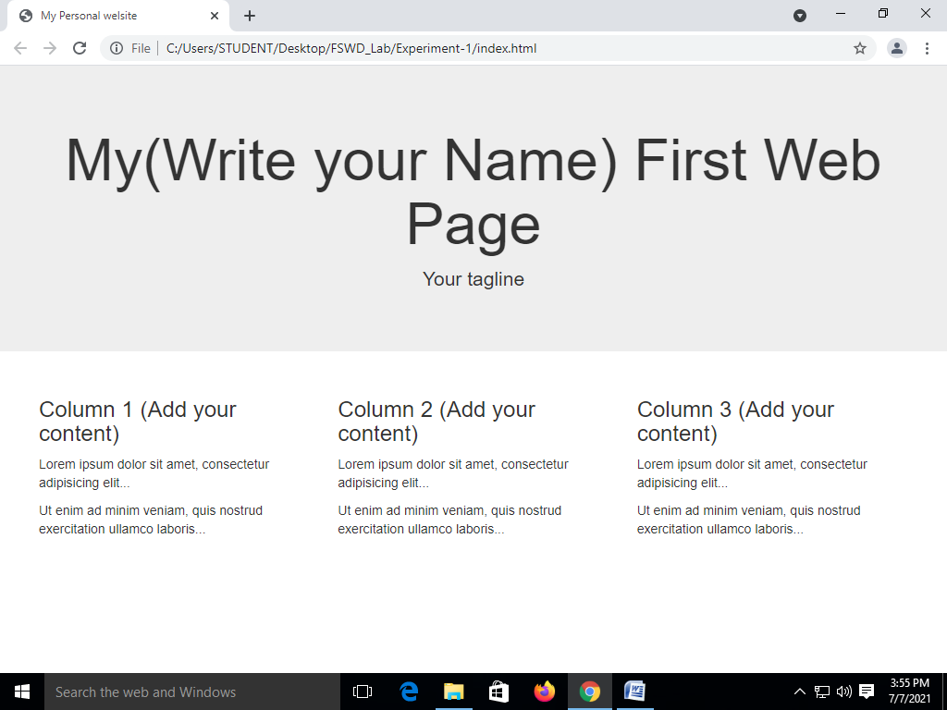
Viva
- What is bootstrap Grid System?
- What is jumbotron in bootstrap?
- What is image map in HTML5?
- What is <Div> tag?
- What is <fig> in HTML5?
- What are the two types of web storage in HTML5?

EXPERIMENT 2: Write CSS5 & HTML5 Code to show Dropdown Menu.

SOURCE CODE:
<!DOCTYPE html>
<html lang="en">
<head>
<title>My Personal welsite</title>
<meta charset="utf-8">
<meta name="viewport" content="width=device-width, initial-scale=1">
<linkrel="stylesheet"href="https://maxcdn.bootstrapcdn.com/bootstrap/3.4.1/css/bootstrap.min.css">
<script src="https://ajax.googleapis.com/ajax/libs/jquery/3.5.1/jquery.min.js"></script>
<script src="https://maxcdn.bootstrapcdn.com/bootstrap/3.4.1/js/bootstrap.min.js"></script>
</head>
<body>
<nav class="navbar navbar-inverse">
<div class="container-fluid">
<div class="navbar-header">
<button type="button" class="navbar-toggle" data-toggle="collapse" data- target="#myNavbar">
<span class="icon-bar"></span>
<span class="icon-bar"></span>
<span class="icon-bar"></span>
</button>
<a class="navbar-brand" href="#">WebSiteName</a>
</div>
<div class="collapse navbar-collapse" id="myNavbar">
<ul class="nav navbar-nav">
<li class="active"><a routerLink="/Home">Home</a></li>
<li class="dropdown">
<a class="dropdown-toggle" data-toggle="dropdown" href="#">Page 1 <span class="caret"></span></a>
<ul class="dropdown-menu">
<li><a href="#">Page 1-1</a></li>
<li><a href="#">Page 1-2</a></li>
<li><a href="#">Page 1-3</a></li>
</ul>
</li>
<li><a href="#">Page 2</a></li>
<li><a routerLink="/About" >About</a></li>
</ul>
<ul class="nav navbar-nav navbar-right">
<li><a href="#"><span class="glyphicon glyphicon-user"></span> Sign Up</a></li>
<li><a href="#"><span class="glyphicon glyphicon-log-in"></span> Login</a></li>
</ul>
</div>
</div>
</nav>
</body>
</html>

OUTPUT:

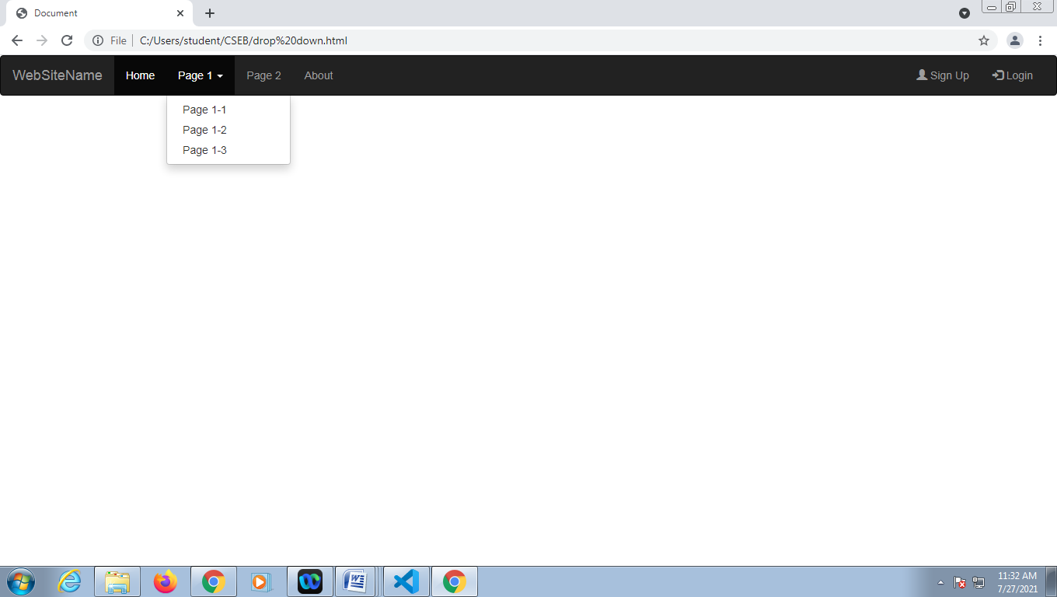
Viva
- What are the CSS frameworks?
- Name some CSS style components?
- What is the importance of Drag and Drop in HTML5?
- What is the global style for bootstrap Default typography?
- Could you explain how to use the dropdown plug-in in bootstrap?

EXPERIMENT 3: Design Single Page Application with different menu items.

SOURCE CODE:

    - npm install -g @angular/cli
    - ng new my-app
    - cd my-app
    - ng serve –open

Opens your browser to http://localhost:4200/

app.component.html

<app-navbar></app-navbar>
<router-outlet></router-outlet>

home.component.html

<p>home works!</p>
<h1>Lorem ipsum, dolor sit amet consectetur adipisicing elit. Rerum, ad? Neque ducimus repellendus enim veniam vel magnam perspiciatis fugit nesciunt?</h1>
<h2>Lorem ipsum dolor sit amet consectetur adipisicing elit. In, aperiam.</h2>

about.component.html

<h1>about works!</h1>
<p>Lorem ipsum dolor sit, amet consectetur adipisicing elit. Consectetur ab natus aperiam, saepe accusantium voluptas dolo</p>

app-routing.module.ts

const routes: Routes = [
{ path: 'Home', component: HomeComponent },
{ path: 'About', component: AboutComponent },
];

OUTPUT:
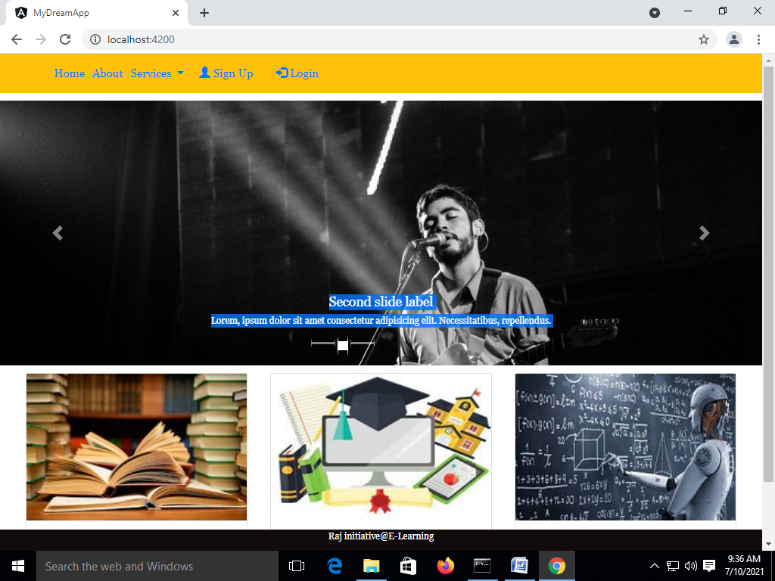
Viva
- Do you know how a navbar works in the bootstrap?
- What is jquery?
- What is the difference between javascript and jquery?
- What is the use of css() method in jquery?
- What is a CND?

EXPERIMENT 4: Write a program in CSS to show your city with building and moving cars.

SOURCE CODE:
Index.html
<!DOCTYPE html>
<html lang="en">
<head>
<meta charset="UTF-8">
<meta http-equiv="X-UA-Compatible" content="IE=edge">
<meta name="viewport" content="width=device-width, initial-scale=1.0">
<title>Moving Cars</title>
<link rel="stylesheet" href="./style.css">
</head>

<body>
<div class="moon"></div>

<div class="skyline">
<div class="building1-shadow"></div>
<div class="building1">

<div class="building-left-half"></div>
<div class="building-right-half"></div>
</div>
</div>
<div class="road">
<div class="road-top-half"></div>
<div class="road-bottom-half"></div>
</div>
<divclass="car-container">
<div class="car-top1">
<div class="window1"></div>
<div class="window2"></div>

</div>
<div class="car-top2">
<div class="door">
<div class="door-knob"></div>
</div>
</div>
<div class="car-bottom">
<div class="wheel1-top"></div>
<div class="wheel1">
<div class="wheel-dot1"></div>
<div class="wheel-dot2"></div>
<div class="wheel-dot3"></div>
<div class="wheel-dot4"></div>
</div>
<div class="wheel2-top"></div>
<div class="wheel2">
<div class="wheel-dot1"></div>
<div class="wheel-dot2"></div>
<div class="wheel-dot3"></div>
<div class="wheel-dot4"></div>
</div>
</div>
</div>
</body>
</html>

style.css
{
box-sizing: border-box;
}
*,
*:before,
*:after {
box-sizing: inherit;
}
body {
overflow: hidden;
height: 100vh;
background: linear-gradient(180deg, #09283d, #1b415c, #29516c, #6e8ea5, #7cadd0, #7cadd0, #7cadd0, #7cadd0, #6e8ea5, #3a6583, #1a4461, #09283d);
background-size: 2400% 2400%;
animation: dayNight 60s ease infinite;
}

@keyframes dayNight { 0%{background-position:25% 0%}
50%{background-position:76% 100%}
100%{background-position:25% 0%}
}
@keyframes driving {
0% {
left: -25%;
}
10% {
bottom: 0%;
}

20% {
transform:scale(0.5)
rotateZ(-5deg);
bottom: 5%
}
25% {
transform: scale(0.5) rotateZ(0deg);
}

40% {
transform: scale(0.5) rotateZ(5deg);
}
50% {
transform: scale(0.5) rotateZ(0deg);
}
100% {
left: 110%;
bottom: 10%;
transform: scale(0.5) rotateZ(0deg);
}
}

@keyframes road-moving {
100% {
transform: translate(-2400px);
}
}
@keyframes wheels Rotation {
100% {
transform: rotate(360deg);
}
}
@keyframes moon {
50% {
transform: translateY(-20px);
}
100% {
transform: translate(80px, -140px);
}
}
@keyframes sun-moon {
from { transform:rotate(0deg); }

to {transform:rotate(360deg); }
}
/* CAR CONTAINER */
.car-container {
position: absolute;
bottom: -10%;
width: 430px;
height: 300px;
animation: driving 5s infinite linear;
transform: scale(0.5);
}
.car-container:after {
content: "";
width: 426px;
height: 1px;
margin-top: 88px;
display: block;
position: absolute;
left: -3%;
z-index: -1;
bottom: 0;
box-shadow: 2px -15px 25px 2px #000000;
}
/* WHEELS */
.wheel1,
.wheel2 {
width:120px;
height: 120px;
background-color: grey;
border-radius: 50%;
border: 20px solid black;
position: absolute;
bottom: 0;
animation: wheelsRotation 1s infinite linear;
}

.wheel1 {
left:5%
}
.wheel1-top,
.wheel2-top
{
bottom: 48px;
position: absolute;
width: 106px;
height: 80px;
border-radius: 50%;
z-index: 5;
box-shadow: 0px 13px 3px 0px rgba(240, 240, 240, 0.53);
transform: rotateX(180deg);
}
}
.wheel1-top{
left:7%
}
.wheel1-top{
right:5%
}
.wheel2{
right:5%
}
.wheel-dot1,
.wheel-dot2
{
width: 10px; height: 25px;
background-color: black;
position: absolute;
}
.wheel-dot3,
.wheel-dot4 {
width: 25px; height: 10px;
background-color: black;
position: absolute;
}
wheel-dot1 {
top: 10%;
left: 45%;
}
.wheel-dot2 {
bottom: 10%;
left: 45%;
}
.wheel-dot3 {
top: 45%;
right: 10%;
}
.wheel-dot4 {
top: 45%;
left: 10%;
}
.door {
width: 110px;
height: 100px;
border: 3px solid #B57A84; position: absolute;
left: 36%;
top: 16px;
border-radius: 10% 40% 10% 10%;
}
.door-knob {
width: 30px;
height: 14px;
background-color: #E8E6E6; border-radius: 30%;
position: absolute;
left: 20%;
top: 5%;
border: 1px solid lightcoral;
}
.car-top1 {
border-radius: 25% 40% 0 0;
background color: #6A1621;
max-width: 100%;
width: 250px;
height: 130px;
position: absolute;
top: 0;
left: 4%;
}
.window1,
.window2 {
background-color: #E2F0F6;
border-radius: 5px;
position: absolute;
width: 40%;
height: 60%;
margin: 17px;
border: 9px solid #BF6D7B;
}
.window1 {
left: 0;
border-top-left-radius: 30%;
}
.window2 {
right: 0;
border-top-right-radius: 50%;
}
.car-top2 {border-radius: 100px 200px 0 0;
background-color: #25659C;
*/ border: 10px solid #72252F;
background-color: #9C2535;
max-width: 100%;
width: 430px;
height: 140px;
position: absolute;
bottom: 20%;
}
.road {
width: 250%;
height: 200px;
background-color: #585858;
border-top: 10px solid #756D6D;
border-bottom: 20px solid #756D6D;
position: absolute;
bottom: 0%;
margin-left: -10px;
padding: 0;
}
.road::before {
content: " ";
position: absolute;
z-index: 0;
top: -17px;
left: 0px;
right: 0px;
border: 5px solid black;
}
.road-top-half {
height: 15px;
width: 250%;
position: absolute;
left: -10%;
top: 30px;
border-top: 40px dashed white;
margin-top: 25px;
animation: road-moving 10s infinite linear;
transition: all 3s linear;
}
.skyline { width: 100%;
position: absolute;
bottom: 205px;
padding: 0;
left: 110%;
animation: road-moving 10s infinite linear;
transition: all 8s linear;
}
.building1 {
width: 220px; height: 450px;
background-color: #211919;
position: relative;
}
.building1-shadow {
border-top: 15px solid transparent; border-right: 60px solid rgb(44, 37, 37); border-bottom:15px solid#000;
border-left:15px solidtransparent; height: 450px;
width:200px; position:absolute; left: -199px;
}
.building-left-half,
.building-right-half {
height: 300px;
width: 50px;
position: absolute;
top: 10px;
border-left: 16px dashed #A9D2C7;
border-right: 16px dashed rgba(255, 255, 0, 0.19);
margin-top: 25px;
}
.building-left-half {
left: 10px; padding: 25px;
}
.building-right-half {
right: 10px;
padding: 20px;
}
.moon {
height: 100px;
width: 100px;
border-radius: 50%;
background: rgb(207, 207, 212);
margin: auto;
box-shadow: 0 0 60px gold, 0 0 100px rgb(185, 160, 24), inset 0 5px 12px 26px #F5F5F5, inset -2px 8px 15px 36px #E6E6DB;
transition: 1s;
transition: 1s;
right:370px;
top: 30px;
position: absolute;
animation: sun-moon 40s 2s linear infinite;
transform-origin: 50% 500px;
}
/*Headlights*/
.car-top1:after
{
width: 13px;
height: 37px;
background-color: #BACCDA;
position: absolute;
bottom: -63px;
right: -168px;
z-index: 10;
content: " ";border-radius: 10px;
border: 2px solid black;
border-left-style: none; transform: rotate(-15deg);
}
.car-top2:after
{
position: absolute;
bottom: 7px;
right: -340px;
content: " ";
width: 0;
height: 0;
border-top: 20px solid transparent;
border-bottom: 80px solid transparent;
border-right: 500px solid rgba(191,188,87,0.7);
z-index: -1;
-webkit-mask-box-image: -webkit-linear-gradient(left, black, transparent);
-webkit-mask-box-image: -o-linear-gradient(left, black, transparent);
-webkit-mask-box-image:linear-gradient(to right, black, transparent);
transform: rotate(-9deg);
}

OUTPUT:
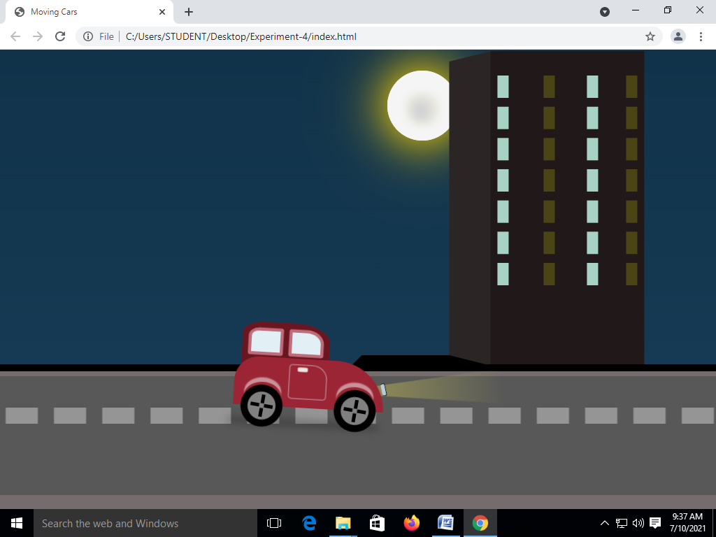
Viva
- Why do we use jquery?
- What are the effects methods used in jquery?
- What is the use of toggle() method in jquery?
- Is it possible that jquery HTML work for both HTML and XML document?
- Is jquery a W3C standard?
EXPERIMENT 5: Write a program to validate web form using JavaScript.
Source Code:
Validation.html
<!DOCTYPE html>
<html>
<head>
<style>
body{
text-align: center; font-family: sans-serif;
}
h1{font-size: 20px;
}
table tr td {
padding-top: 6px;
padding-bottom: 6px;
}
fieldset{width:500px; text-align: center}
</style>
<div id="header">
<h1>Registration</h1>
</div>
<div id="content">
<meta http-equiv="Content-Type" content="text/html; charset=UTF-8">
<title>Register</title>
</head>
<script>
function validate()
{
var fn = frm.fname.value;
for(x in fn)
{
ch=fn.charCodeAt(x);
if(ch<65||ch>90 && ch<97||ch>122)
{
alert("Invalid firstname");
return false;
}
}
var ln = frm.lname.value;
for(y in ln)
{
ch=ln.charCodeAt(y);
if(ch<65||ch>90 && ch<97||ch>122)
{
alert("Invalid lastname");
return false;
}
}
var phn = frm.phone.value;
var lenp = phn.length;
if (lenp!==10)
{ alert("Phone no should be exactly 10 digits");
return false;
}
var pwd1=frm.pwd.value;
var pwdl=pwd1.length;
if(pwdl%2===1)
{
alert("Password should contain even number of characters");
return false;
}
if(pwdl > 8)
{
alert("Password should not exceed 8 digits");
return false;
}
var reg = /^\w+([-+.']\w+)*@\w+([-.]\w+)*\.\w+([-.]\w+)*$/;
var mail=frm.mailid.value;
if (reg.test(mail)){
alert("Valid email"); }
else{
alert("Invalid email");
return false;
}
return true;
}
</script>
<div id="container">
<body>
<center>
<form name="frm" method="POST" action="success.html" onSubmit="return validate()">
<fieldset align="center">
<table align="center">
<tr><td>First Name: </td><td><input type="text" name="fname" value="" size="50" required/></td></tr>
<tr><td>Last Name: </td><td> <input type="text" name="lname" value="" size="50" required/></td></tr>
<tr><td>Phone No: </td><td> <input type="text" name="phone" value="" size="50" required/></td></tr>
<tr><td>Mail id:</td><td><input type="email" name="mailid" value="" size="50" required/></td></tr>
<tr><td>Gender:</td>
<td>Male: <input type="radio" name="gender" value="male" >
Female: <input type="radio" name="gender" value="female"></td></tr>
<tr><td>DOB :</td><td><input type="date" name="dob" size="50" required/></td></tr>
<tr><td>Username:</td><td><input type="text" name="uname" value="" size="50" required/></td></tr>
<tr><td>Password:</td><td><input type="password" name="pwd" value="" size="50" required/></td></tr>
<tr><td>Age:</td><td><input type="text" name="age" value="" size="50" required/></td></tr>
</table>
<input type="submit" value="SUBMIT" name="submit" />
</fieldset>
</form>
</div>
</center>
</body>
<div id="footer">
Copyright © CMRIT_2022
</div>
</div>
</html>
Success.html
<!DOCTYPE html>
<html>
<body>
<h1>Registration completed</h1>
</body>
</html>

Output:
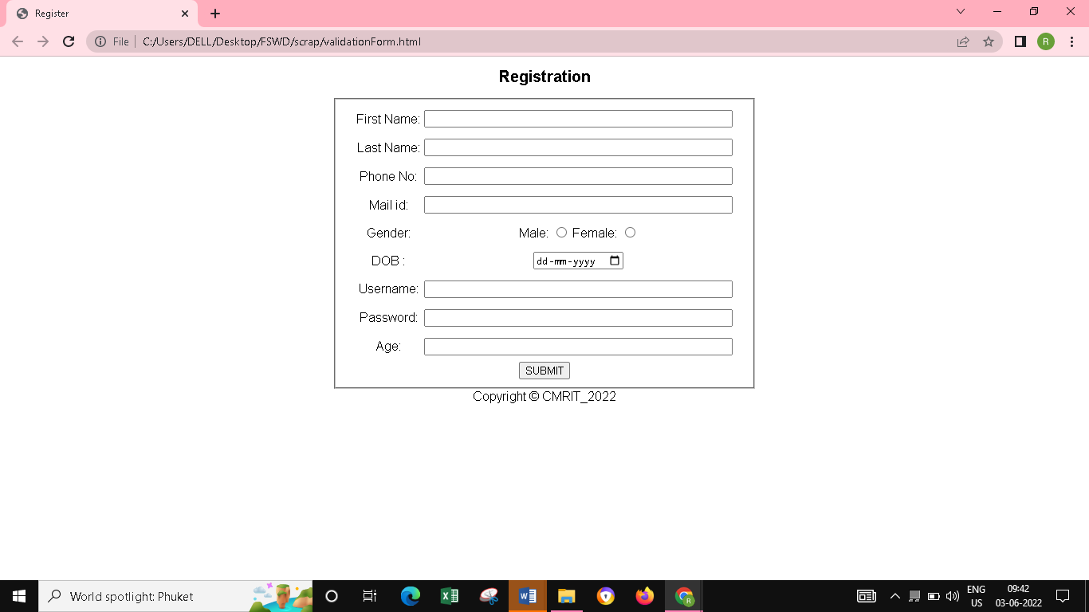

Viva
- What is AJAX?
- What Are The Security Issues With AJAX?
- What are the tools for debugging AJAX application?
- What are the common AJAX frameworks?
- What is jquery filter method?

EXPERIMENT 6: Write jquery code to show website slider.
Source Code
Corousel.html:
<!DOCTYPE html>
<html lang="en">
<head>
<title>JQuery Slider</title>
<meta charset="utf-8">
<meta name="viewport" content="width=device-width, initial-scale=1">
<link rel="stylesheet"href="https://maxcdn.bootstrapcdn.com/bootstrap/3.4.1/css/bootstrap min.css">
<script src="https://ajax.googleapis.com/ajax/libs/jquery/3.5.1/jquery.min.js"></script>
<script src="https://maxcdn.bootstrapcdn.com/bootstrap/3.4.1/js/bootstrap.min.js"></script>
</head>
<body>
<div class="container">
<div id="myCarousel" class="carousel slide">
<ol class="carousel-indicators">
<li class="item1 active"></li>
<li class="item2"></li>
<li class="item3"></li>
</ol>
<div class="carousel-inner" role="listbox">
<div class="item active">
<img src="1.jpg" alt="image1" width="100%" height="100%">
</div>
<div class="item">
<img src="2.jpg" alt="image2" width="100%" height="100%">
</div>
<div class="item">
<img src="3.jpg" alt="image3" width="100%" height="100%">
</div>

</div>
<a class="left carousel-control" href="#myCarousel" role="button">
<span class="glyphicon glyphicon-chevron-left" aria-
hidden="true"></span>
<span class="sr-only">Prev</span>
</a>
<a class="right carousel-control" href="#myCarousel" role="button">
<span class="glyphicon glyphicon-chevron-right" aria-
hidden="true"></span>
<span class="sr-only">Next</span>
</a>
</div>
</div>
<script>
$(document).ready(function(){
$("#myCarousel").carousel();
$(".item1").click(function(){
$("#myCarousel").carousel(0);
})
$(".item2").click(function(){
$("#myCarousel").carousel(1);
})
$(".item3").click(function(){
$("#myCarousel").carousel(2);
})
$(".left").click(function(){
$("#myCarousel").carousel("prev");
})
$(".right").click(function(){
$("#myCarousel").carousel("next");
})
});
</script>
</body>
</html>

OUTPUT:

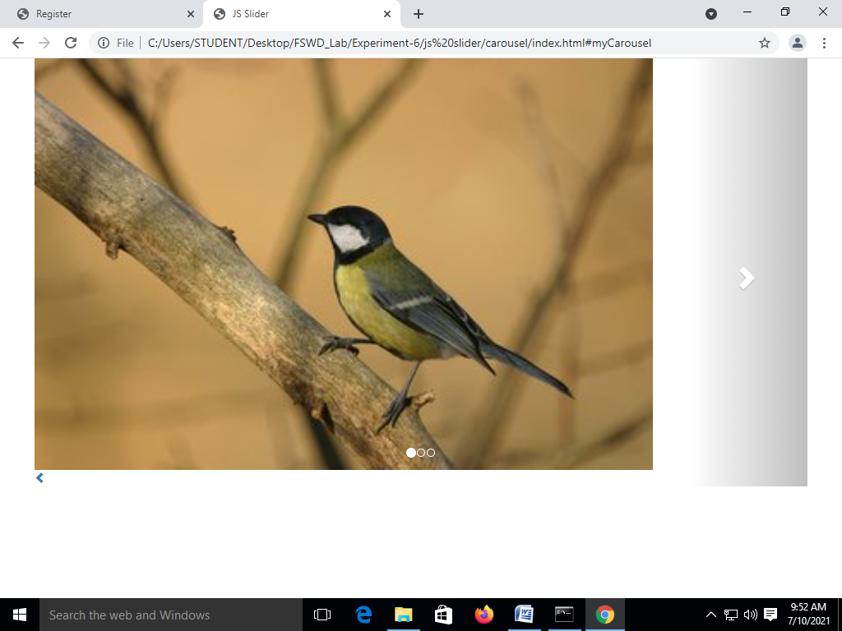

Viva

What are the jquery methods used for provide effects?
- Which command will give a version of jquery?
- What are the basic selectors in jquery?
- What is the use of jquery load method?
- What are the two types of CNDs?
EXPERIMENT 7: Write a program in javascript to create a user login system.
Source Code:
Login.pug:

doctypehtml
html(lang="en")
head
meta(charset="UTF-8")
meta(http-equiv="X-UA-Compatible", content="IE=edge")
meta(name="viewport", content="width=device-width, initial-scale=1.0")
title Login
style
include ./my.css
body
div(class='container')
include ./index.pug
h1 Login form
br
form(action="/Login" method="post" align="center")
label(for="username") username
input(type="text" name="username")
br
br
label(for="password") password
input(type="password" name="password")
br
br
input(type="submit" name="Login" value="Login")
Style.css
h1{
color:blue;
text-align:center;
}
a:link,a:visited{
background-color: brown;
color:white;
padding:14px 25px;
text-align: center;
display: inline-block;
}
a:hover,a:active{
background-color: chartreuse;
}
.header {
padding: 10px;
text-align: center;
background: #1abc9c;
color: white;
font-size: 30px;
}
.container {
border-radius: 5px;
background-color: #f2f2f2;
padding: 10px;
}
input{
width: 20%;
padding: 12px;
border: 1px solid #ccc;
margin-top: 6px;
margin-bottom: 16px;
resize: vertical;
}
input[type=submit] {
background-color: #04AA6D;
color: white;
padding: 12px 20px;
border: none;
cursor: pointer;
}
input[type=submit]:hover {
background-color: #45a049;
}
label{
color: blue;
font-size: 22px;
padding: 8px;
text-align:left;
}

App.js
Const express=require('express');
const bodyparser=require("body-parser")
const bcrypt=require("bcrypt");
const user=require('./models/user');
const mongoose = require('mongoose');
const expressValidator = require("express-validator");
const {check, validationResult} = require('express-validator/check')
const app = express();
const port = process.env.PORT || 80
mongoose.connect("mongodb://localhost:27017/user",{userNewUrlP
arser : true});
app.set('view engine', 'pug');
app.use(bodyparser.json());
app.use(bodyparser.urlencoded({extended:true}));
//handling get request
app.get('/',function(req,res){
res.render('index')
})
app.get('/Login',function(req,res){
res.render('Login')
})
//handling post request
app.post('/Login',function(req,res){
user.findOne({username:req.body.username},function(err,docs){
if(err)
{
console.log(err)
}
else

{
if(docs.username==req.body.username)
{
bcrypt.compare(req.body.password,docs.password,function(err,data)
{
if(err)
{
console.log(err);
}
if(data)
{
console.log(data);
res.send("Welcome");
}
else
{
res.send("invalid password");
}
});
}
else
{
//res.send("invalid username or password")
res.redirect("Register");
}
}
})
})
app.listen(port,() => {console.log(`app is listening on http://localhost:${port}`)})

Models/user.js
const mongoose=require('mongoose');
const Schema=mongoose.Schema;

const userSchema=new Schema(
{
username : {type:String},
password : {type:String},
age : {type:Number},
mobile : {type:Number}
}
);
module.exports=mongoose.model("user",userSchema);

OUTPUT:

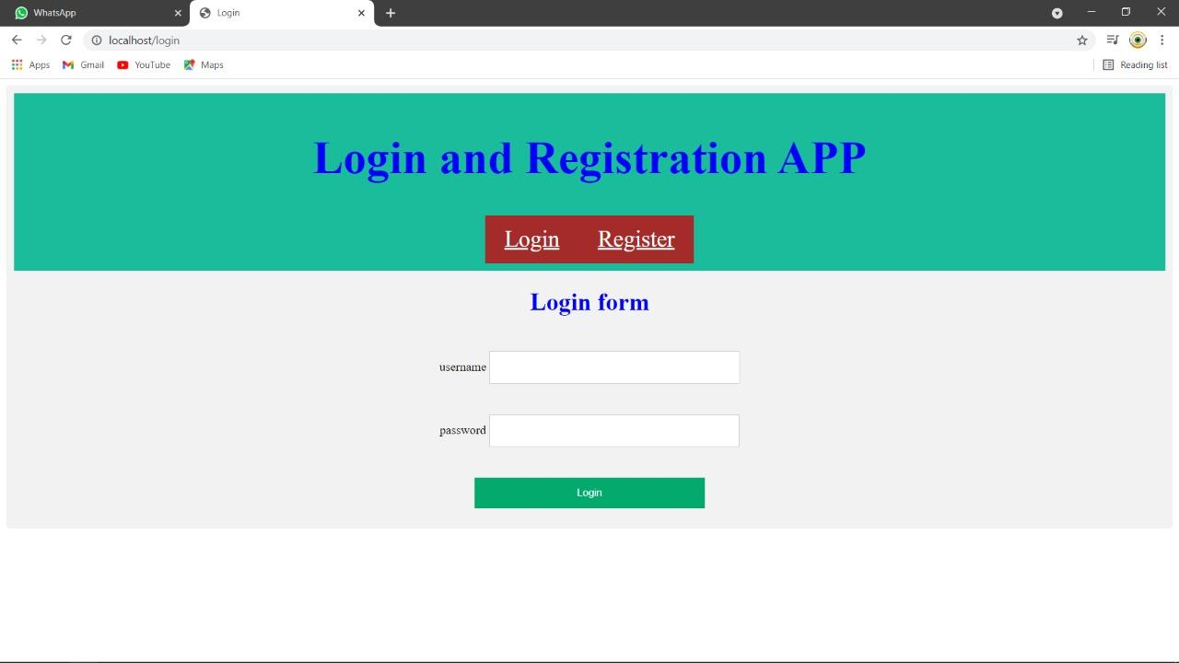
Viva
- Explain key features of bootstrap?
- Define the key components of bootstrap?
- What are the different button styles in bootstrap?
- What are bootstrap alerts?
- Why bootstrap is used for mobile web development?

EXPERIMENT 8: Write a program in javascript to create a user registration system.
Source Code:
Register.pug

doctypehtml
html(lang="en")
Head
meta(charset="UTF-8")
meta(http-equiv="X-UA-Compatible", content="IE=edge")
meta(name="viewport", content="width=device-width, initial-scale=1.0")
title Register
style
include ./my.css
body
div(class='container')
include ./index.pug
h1 Registration form
ul(id="errors")
Br
form(action="/Register" method="post" align="center")
label(for="username") username
input(type="text" name="username")
Br
Br
label(for="password") password
input(type="password" name="password")
Br
label(for="cpassword") Confirm password
input(type="password" name="cpassword")
Br
Br
label(for="age") user age
input(type="text" name="age")
Br
Br
label(for="mobile") user mobile
input(type="text" name="mobile")
Br
label(for="email") user email
input(type="text" name="email")
Br
Br
input(type="submit" name="Register" value="Register")

App.js

Const
express=require('express’);
const bodyparser=require("body-parser") const bcrypt=require("bcrypt");
const user=require('./models/user'); const mongoose = require('mongoose');
const expressValidator = require("express-validator");
const {check, validationResult} = require('express-validator/check') const app = express();
const port = process.env.PORT || 80 mongoose.connect("mongodb://localhost:27017/user",{userNewUrlParser : true}); app.set('view engine', 'pug');
app.use(bodyparser.json()); app.use(bodyparser.urlencoded({extended:true}));
//handling get request app.get('/',function(req,res){ res.render('index')
})
app.get('/Register', function(req, res){

res.render('Register')
})
//handling post request
app.post('/Register', [
check('username').not().isEmpty().isLength({min:5}).withMessage('User name must be 5 characters'), check('password').not().isEmpty().isLength({min:6}).withMessage('Password name must be 6
characters'),
check('mobile').not().isEmpty().isInt().isLength({min:10}).withMessage('mobile number must be
number and 10 characters'),
check('cpassword').custom((value,{req}) => (value === req.body.password)).withMessage("Confirm password not match with your password"),
check('email').not().isEmpty().isEmail().normalizeEmail().withMessage("Enetr proper email"),
],
function(req,res){
const errors= validationResult(req);
if(!errors.isEmpty())
{
return res.status(422).jsonp(errors.array());
}
else{
//console.log(req.body.username)
const newUser=new user();
newUser.username=req.body.username;
var salt=bcrypt.genSaltSync(10);
varhash=bcrypt.hashSync(req.body.password,salt);
newUser.password=hash;
newUser.age=req.body.age;
newUser.mobile=req.body.mobile;
newUser.save(function(err,result){
if(err){
console.log(err);
}
else{
console.log(result);
res.redirect("Login");

}

})

}
})

})

app. listen(port,() => {console.log(`app is listening on http://localhost:${port}`)})

Model/users.js

Const mongoose=require('mongoose');
const Schema=mongoose. Schema;
const user Schema=new Schema(
{
username : {type: String},
password : {type: String},
age : {type: Number},
mobile : {type: Number}
}
);
module.exports=mongoose. model("user",userSchema);

OUTPUT:

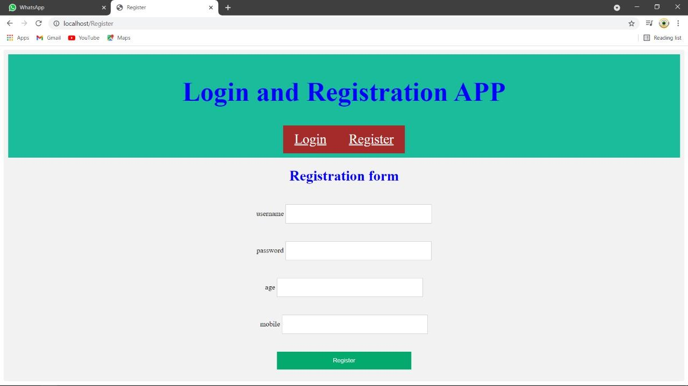
Viva
- What is the purpose of xmlhttprequest?
- What are the properties of xmlhttprequest?
- What are the technologies used by AJAX?
- What are the types of send() method used for XMLhttprequest?
- Describe MVC in reference to anjular?
EXPERIMENT 9: Write a program to display user details using HTML, CSS &amp; AJAX.
Source Code:
Ajax.pug:

doctype html
html(lang"en")
head
meta(charset="UTF-8")
meta(http-equiv="X-UA-Compatible",content="IE=edge") meta(name="viewport",content="width=device-width,initial-scale=1.0")
title Login
style
include./my.css script(src="http://code.jquery.com/jquery-3.1.0.min.js") script(src="/magic.js")
include ./index.pug
body
div(class='container')
form(method="post" id="change" align="center") input(type='text', placeholder='search user', name='name') input(type="submit", value="Search")
br
h1 User Details p !{name}

/public/magic.js

$(document).ready(function(){
$("form#change").on('submit',function(e)
{
e.preventDefault();
var data = $('input[name=name]').val();
$.ajax({
type: 'post',
url: '/ajax',
data:data,
dataType: 'text'
})
.done(function(data){
$('h1').html(data.name);
});
});
});
App.js
const express = require('express');
const bodyparser=require("body-parser")
const bcrypt=require("bcrypt");
const user=require('./models/user');
const mongoose=require('mongoose');
const expressValidator = require("express-validator");
const {check, validationResult} = require('express-validator/check')
const app = express();
const port = process.env.PORT || 80
mongoose.connect("mongodb://localhost:27017/user",{userNewUrlParser : true}); app.set('view engine', 'pug');
app.use(bodyparser.json()); app.use(bodyparser.urlencoded({extended:true});
app.get('/ajax', function(req, res){
res.render('ajax', {title: 'An Ajax Search', name: "Search user!"});
});

app.post('/ajax', function(req, res){
user.findOne({username:req.body.name},function(err,docs)
{
if(err)
{
console.log(err)

}
else
{

res.render('ajax', {title: 'An Ajax search', name: "Name "+docs.username+", Age "+docs.age+", Mobile "+docs.mobile });

}

});
});

app.listen(port,() => {console.log(`app is listening on http://localhost:${port}`)})

OUTPUT:

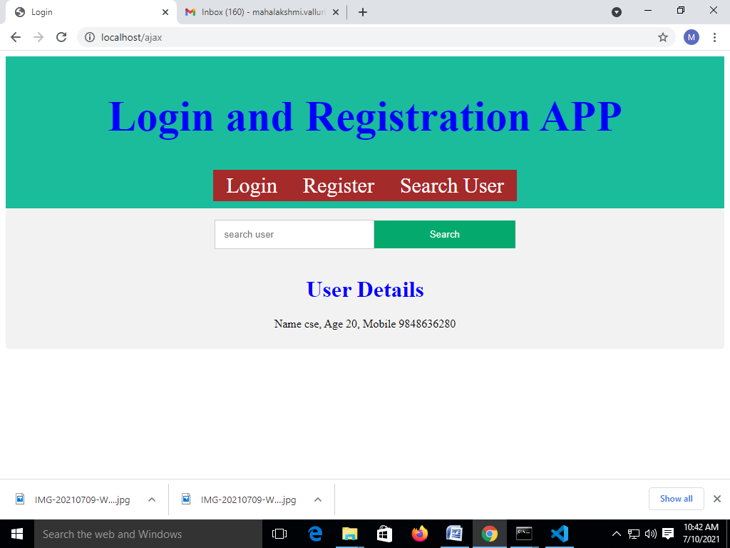

Viva
- What is the purpose of branching in git?
- Mention the various git repository hosting functions?
- What is data binding in Anjularjs?
- What are the common AJAX frameworks?
What are the directives in anjularjs?
EXPERIMENT 10: Demonstrate version control in Git and Github.
Source Code:
$ git config --global user.name "cmr"
$ git config --global user.email cmr@example.com

Index.html
<h1>welcome to my web page</h1>
git init git add .
git commit -m "Hello world"

Index.html
<h1>welcome to my web page</h1>
<p>My first website</p>

git add .
git commit -m "paragraph added"
git log git staus
git branch -M main
git remote add origin url
git push –u origin main
OUTPUT:
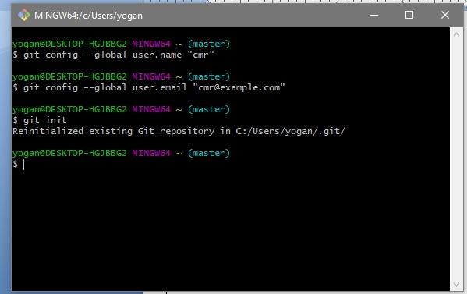
Viva
- What is git?
- What is the difference between git and github?
- What are the benefits of version control system?
- What is a repository in git?
- How to create a repository in git?
- What is the difference between git pull and git fetch?

